Mrs Matharu’s group Comprehension Thursday 14th January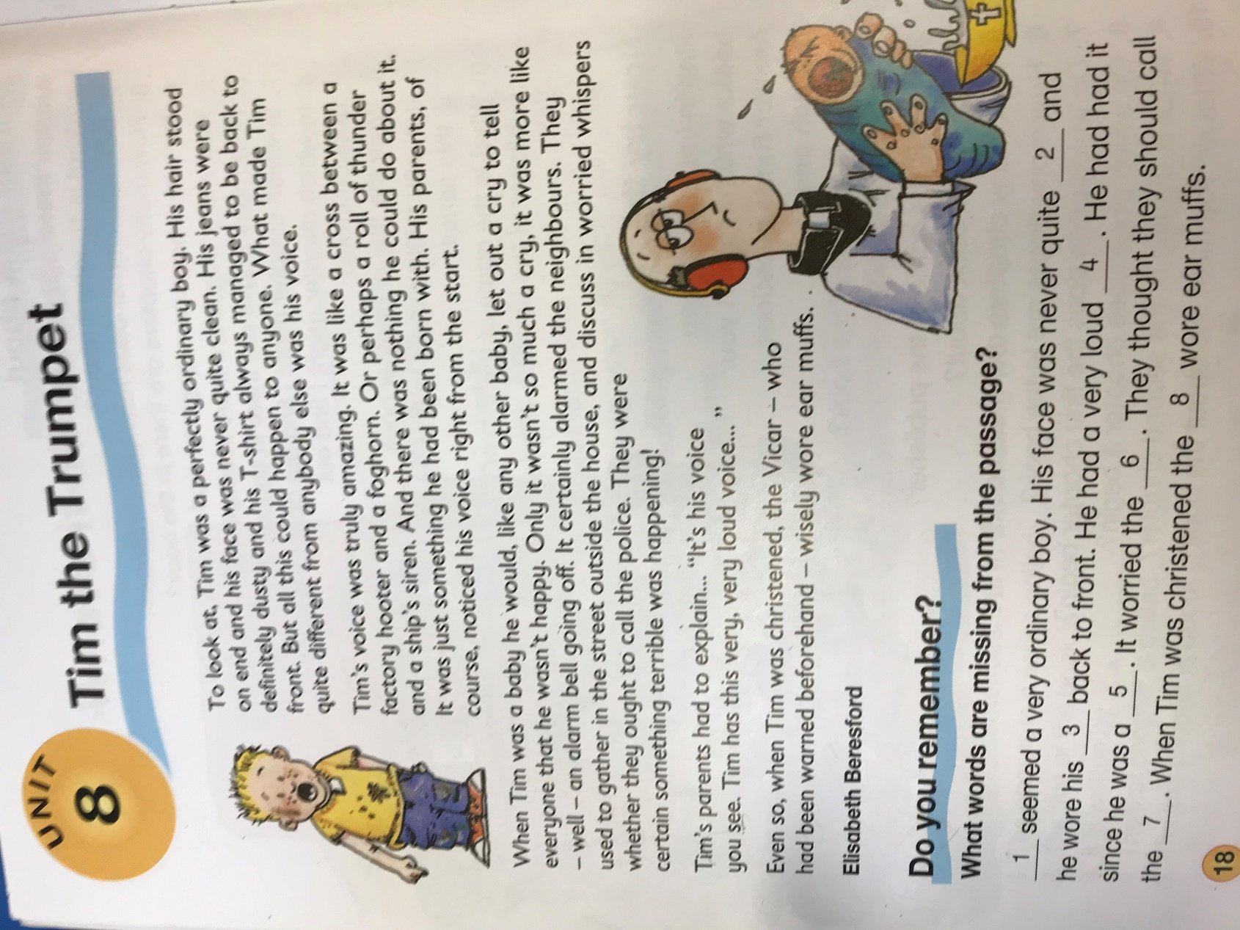

More questions : More to think about

