Topic | Learning objective | Teaching points /teachers voice | Task to complete
English | LO To understand how to use hyphens | Watch the Powerpoint : Year 6 Home school Learning English Presentation Hyphens  Click on  to run the slide show. | Use worksheet  Mrs Matharu’s Group Use  Year 6 Home school learning English Avoiding ambiguity One Star  All others use  Year 6 Home school learning English Avoiding ambiguity Three star sheet  Self- mark your work  Then if you want to test yourself use:  Year 6 Home school learning English worksheet Hyphens mini test  Self -mark you work at the end.
Spelling | LO  To spell homophones | Spelling Frame  Spelling test day. | Use the online spelling test  or ask someone in your house to test you – ask them to read the spellings out not in order. (Make sure they put the word into a sentence, like your teacher would).
Maths  SEE BELOW IF You are in Mrs Matharu’s Maths group | LO To solve algebra problems | DOODLE MATHS DAILY FOR 15 Minutes  We are doing more algebra today  Watch video: https://vimeo.com/425605040  Extension work BELOW  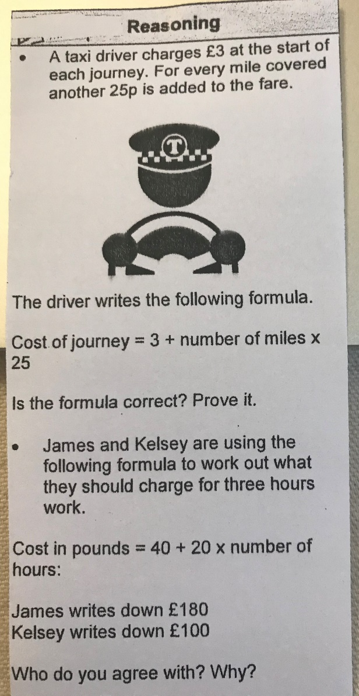 | All to do Homeschool Learning Maths Friday sheet  Mark your work using answers  Extension work see left
Mrs Matharu’s Maths group | Practise timetables  Increase recall speed of times tables. | Fun Friday!  Well done for doing the work this week. We have completed our unit on column addition and subtraction. Next week we will be moving onto dividing. This involves knowing how to work out our times tables (donkey work).  Can you count in 6s- 6, 12, 18….(just keep adding 6)  7s- 7, 14, 21…(just keep adding 7)  9s- 9, 18…(just keep adding 9)  Are you correct?  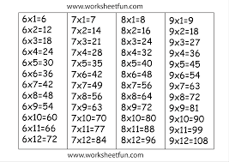 | Remember the multiplication square we fill in at school. Can you do this in 13 minutes?  Challenge yourself.  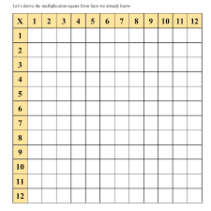  Have a go on any of the times tables games on this website  www.topmarks.co.uk/maths-games/7-11-years/times-tables  Remember don’t just do the easy times tables! Do x6, x7, x8 and x9. This will help you next week.  Enjoy your weekend.  Mrs Matharu
Topic | To be active | We would like you to do some PE.  You can go onto the genius Joe Wicke’s PE lessons.  Here is his one for Monday 11 January 2021  https://www.youtube.com/watch?v=tSi2ix1i180  And/or you can try out some yoga. This Yoga workout is great.  The teacher in this video has really got me to try yoga. It helps to calm me, makes my core and arms strong and makes my mind strong and ready to face all the challenges we face. It is awesome. You are all awesome!  https://www.youtube.com/watch?v=Td6zFtZPkJ4 | See my notes left.  Send us a photo of you being active.  You will be amazed at how brilliant you are (and if either is hard, make sure you give it another go as on another day to get better).

If you have any questions about today’s learning activities set then please email the class email these are viewed from 9.00 until 4.00 daily.

