Topic | Learning objective | Teaching points /teachers voice | Task to complete
English  Grammar lessons  (From Oak academy) | 1)LO to revise and explore simple sentences.  2)LO revising main clauses and subordinate clauses to write complex sentences. | Web page :  https://classroom.thenational.academy/units/t1-sentence-level-objectives-2d3b  Mrs Matharu’s group and orange group please do challenge 1  Add the link to your web browser by copying it or cutting and pasting it in.  1)challenge 1 . Please watch the video called  Lesson 1. To explore simple sentences. ( image below)  Please watch this short teaching clip and answer the questions set.  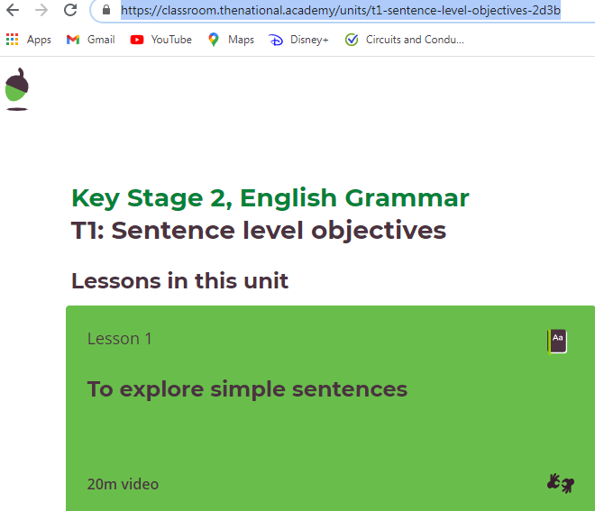  2) challenge 2 ( brown, pink and green groups ) please load up the same web page but I would like you to watch lesson 4.  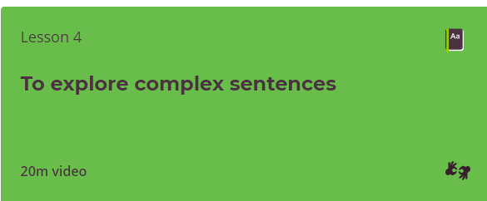  Pink and green suggested challenge 2.  Brown group suggested challenge 3. | 1) Challenge 1. ( Mrs Matharu’s group and orange)  Lesson 1. Watch the video, pause it as required and  answer the questions .  Using the success criteria in the video, write at least 4 sentences of  your own telling me about your Christmas holiday.  2) Challenge 2. ( pink, green groups)  Lesson 4. Watch the video, pause it as required and answer the questions.  Using the success criteria in the video, write at least 6 sentences of  your own telling me about your Christmas holiday.  3) challenge 3.( Brown group)  Lesson 4. Watch the same video as challenge 2, pause it as required  and answer the questions.  Using the success criteria in the video, write at least 10 sentences  of your own telling me about your Christmas holiday.  Start each sentence with a subordinating clause and don’t forget to  add your comma!
Maths | LO place value, ordering and comparing numbers beyond 1000. | You will self-select your challenge depending on how confident you feel.  ( 3 levels of difficulty are need to practice, confident and uber confident) if you find the level too easy, please go onto the next challenge.  Need to practice- Challenge 2 ( parts 1 and 2 ) from the Busy Ants page  (image on the right)  Confident use all 8 of the numbers in Busy Ants challenge 2, part 2 ( 4761, 3981, 5003 etc) order the numbers from the smallest to the largest then add 400 to each number and subtract 400 from each number.  Game to reinforce place value – try a challenge  http://www.math-play.com/Place-Value-Millionaire/place-value-millionaire-game_html5.html  In this game you can change the challenge and it checks your answers too  http://ictgames.com/rangeArranger/ | 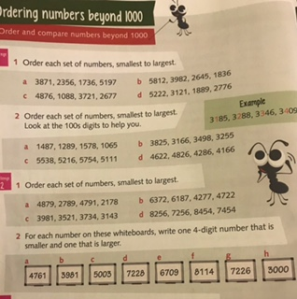  Challenge 1  Challenge 2- table below ( +/- 400)  Uber confident do the 4 digit target challenge below.  A little trick- Write the numbers on a piece of paper/post-it  so you can move them around easily.  Challenge 3  4 digit targets.  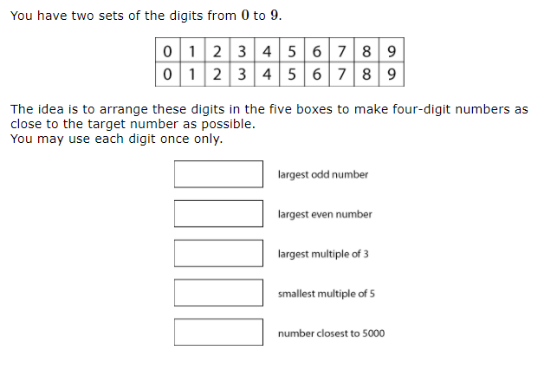
  - 400 | Original number  Before you + and - Order these numbers smallest to largest) | +400
  Eg. 600 | 1000 | 1400
   | 4761
   | 3981
   | 5003
   | 7228
   | 6709
   | 8114
   | 7226
   | 3000
Topic  History  Ancient Rome. | LO To find out 5 fun facts about Ancient Rome. | If possible , Search the internet. Use words like  fun facts for kids about Ancient Rome.  This will make sure that websites will be child friendly and you will be able to understand their content.  Choose 5 fascinating facts to write about/ draw.  This is a good site.  https://www.ducksters.com/history/ancient_rome.php | Create an A4 poster about Ancient Rome, just use key words to  show me what you were researching.  Here is an example of a simple poster to inspire you .  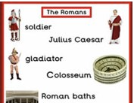

Please take a photo and email the work daily.
If you have any questions about the learning activities set then please email the class email . These are viewed from 9.00 until 4.00 daily.

