Maths answers 11.1.2021

 | Challenge 1 | Challenge 2
 | 3 x2=6 | 11 x 9 = 99
 | 5 x 5=25 | 6 x 9 = 54
 | 2 x 10 = 20 | 12 x 7 = 84
 | 10 x 6 = 60 | 9 x 6 = 54
 | 11 x 4 = 44 | 7 x 7 = 49
 | 2 x 9 = 18 | 12 x 9= 108
 | 5 x 4 = 20 | 11 x 11 = 121
 | 10 x 8= 80 | 5 x 9 = 45
 | 11 x 7 = 77 | 8 x 8 = 64
 | 2 x 6 = 12 | 9 x 13 = 117
 | 5 x 8 = 40 | 12 x 11= 132
 | 10 x 10 =100 | 9 x 9 = 81
 | 11 x 3= 33 | 7 x 6 = 42
 | 2 x 8= 16 | 8 x 7 = 56
 | 5 x 9= 45 | 12 x 12= 144
Challenge 1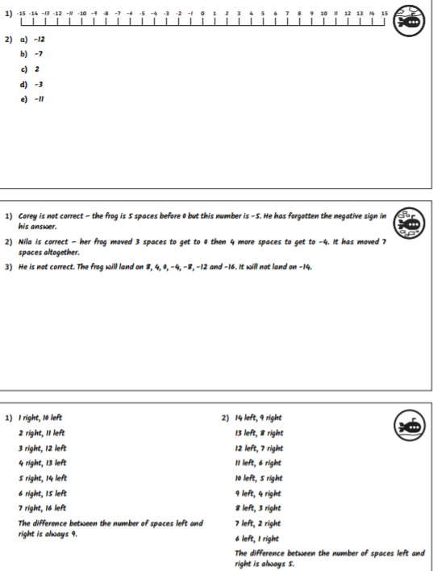

Challenge 2
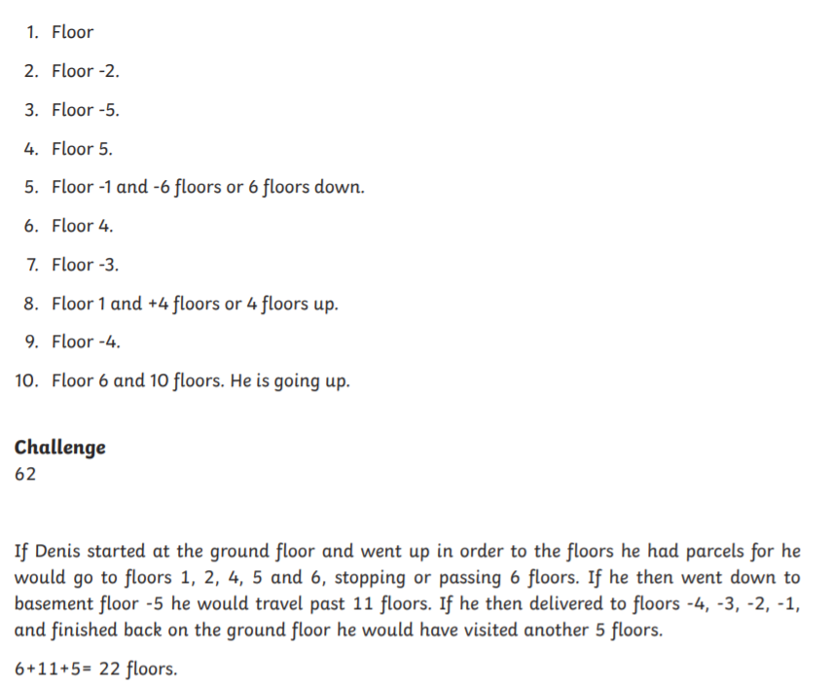

Challenge 3


