Challenge 1
Aim: To answer word problems involving negative numbers

- The temperature on Tuesday was 5°C. On Wednesday it was 6 degrees colder. What was the temperature on Wednesday?

- The temperature on Friday was -7°C. The following the day, the temperature rose by 9 degrees. What was the temperature the following day and what day would it have been?

- The temperature in Sweden was -8°C. In Birmingham it was -2°C. Which place was colder?

- What is 7 minus 11?

- How many degrees more is 2°C than -2°C?

- Increase -3 by 6.

- What is 3 minus 10?

- The temperature in Sydney was 14°C. The following day it dropped by 27°C. What was the temperature on the following day?

- The temperature is -9°C in Scotland. If it is 8°C warmer in Datchet, what will the temperature be in Datchet?

- The temperature was -6°C in Finland. The following day it was 9 degrees warmer. What was the temperature on the following day?

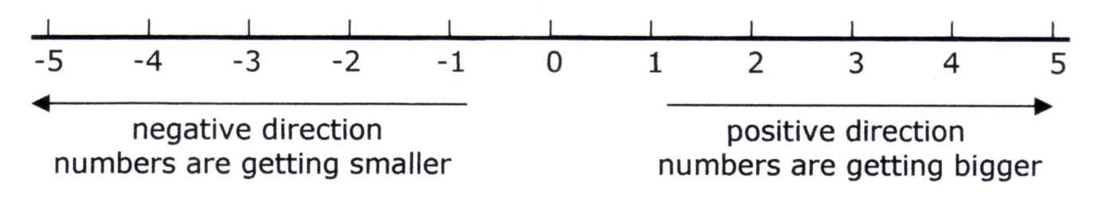

Challenges 2 and 3
Aim: To answer word problems involving negative numbers

  - In a quiz one point is scored for each correct answer but a point is deducted ( subtracted) for every wrong answer.
    - If a team gets five questions right and seven questions wrong what is their final score?

  - In November one day the temperature was 18°C. During the night the temperature dropped by 29 degrees. What was the temperature during the night?

  - Westfields shopping centre has floors below as well as above ground. If I start at the fifth floor and go down eight floors how many floors below ground level will I be?

  - One day in December the temperature was 4°C. During the night the temperature dropped to -5°C. How many degrees colder was it in the night than in the day?

  - In a quiz five points are scored for each correct answer but five points are taken away for every wrong answer.
    - If a team gets seven questions right and 10 questions wrong what is their final score?

  - The Burj Kalifa in Dubai has floors below as well as many above ground. If I start at the 35th floor and end up 18 floors below ground level, how many floors have I travelled through?
  - Write two of your own question where the answer are -22 and -15. Give them to your adult to solve.

  - Where else in real life would you use or see negative numbers?

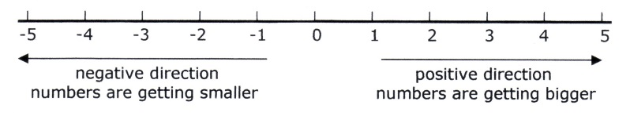

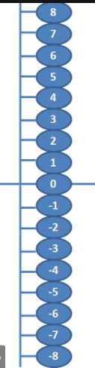
Negative number lines can be vertical or horizontal, they show positive numbers ( above 0) and negative numbers ( below 0)
Resources to make. Make a vertical number line that starts at 20 at the top and goes down to -20 at the bottom. This will be useful for today’s work.

