Challenge 1
Aim: To answer word problems involving negative numbers

- The temperature on Tuesday was 5°C. On Wednesday it was 6 degrees colder. What was the temperature on Wednesday? -1

- The temperature on Friday was -7°C. The following the day, the temperature rose by 9 degrees. What was the temperature the following day and what day would it have been? Saturday , 2

- The temperature in Sweden was -8°C. In Birmingham it was -2°C. Which place was colder? Sweden.

- What is 7 minus 11? – 4

- How many degrees more is 2°C than -2°C? 4

- Increase -3 by 6. 3

- What is 3 minus 10? -7

- The temperature in Sydney was 14°C. The following day it dropped by 27°C. What was the temperature on the following day? -13

- The temperature is -9°C in Scotland. If it is 8°C warmer in Datchet, what will the temperature be in Datchet? -1

- The temperature was -6°C in Finland. The following day it was 9 degrees warmer. What was the temperature on the following day? 3 degrees Celsius.

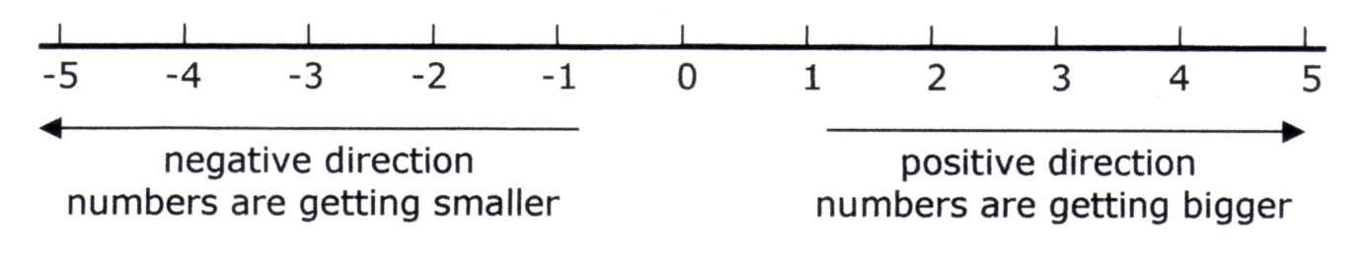

Challenges 2 and 3
Aim: To answer word problems involving negative numbers

  - In a quiz one point is scored for each correct answer but a point is deducted ( subtracted) for every wrong answer.
    - If a team gets five questions right and seven questions wrong what is their final score? -2

  - In November one day the temperature was 18°C. During the night the temperature dropped by 29 degrees. What was the temperature during the night? -11

  - Westfields shopping centre has floors below as well as above ground. If I start at the fifth floor and go down eight floors how many floors below ground level will I be? 3 floors below ground ( -3)

  - One day in December the temperature was 4°C. During the night the temperature dropped to -5°C. How many degrees colder was it in the night than in the day? 9 degrees colder

  - In a quiz five points are scored for each correct answer but five points are taken away for every wrong answer.
    - If a team gets seven questions right and 10 questions wrong what is their final score? -15

  - The Burj Kalifa in Dubai has floors below as well as many above ground. If I start at the 35th floor and end up 18 floors below ground level, how many floors have I travelled through? 53
  - Write two of your own question where the answer are -22 and -15. Give them to your adult to solve. check correct context.

  - Where else in real life would you use or see negative numbers? various answers including bank balances. ( link to economic awareness)

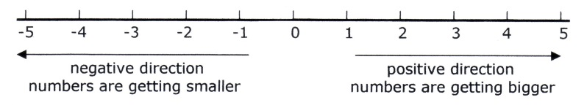

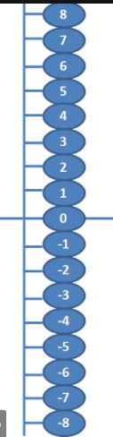
Negative number lines can be vertical or horizontal, they show positive numbers ( above 0) and negative numbers ( below 0)
Resources to make. Make a vertical number line that starts at 20 at the top and goes down to -20 at the bottom. This will be useful for today’s work.

