Subtracting – word problems and reasoning.
LO: I can solve and create my own subtraction worded problems.
1. There are 565647 children watching a virtual charity football match. 38652 were Man city supporters. How many children were Chelsea supporters?
2. A huge container of water has 856782 l of water in it. Adam spills 767026 l out. How much water is left?
3 and 4 . your turn …write 2 worded problems .
5. see below.
6. below 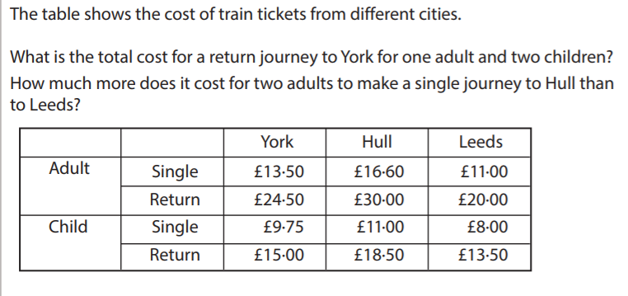
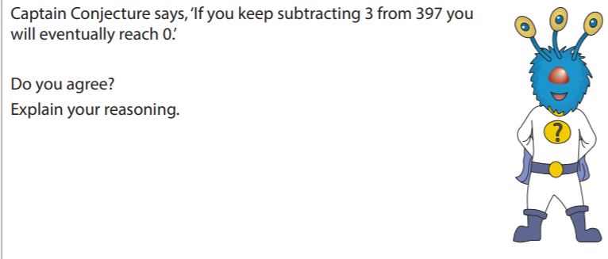
7/8/. Create your own worded problems involving money for your parents to solve.

Try this for fun.
https://www.sheppardsoftware.com/math/subtraction/fruit-splat-game/
You can change the level of challenge. I would ensure it’s timed !

Answers
- 526995
- 89756
- Own subtraction worded problem
- Own subtraction worded problem
- £54.50
£11.20
- Accept any suitable answers such as if you divide 397 by 3 you get 132.3’
- And 8. Decimal subtraction – ensure that the worded problem makes sense

