26.1.2021 acute, obtuse and reflex angles. BA, 4B, Pg 13
Challenge 1
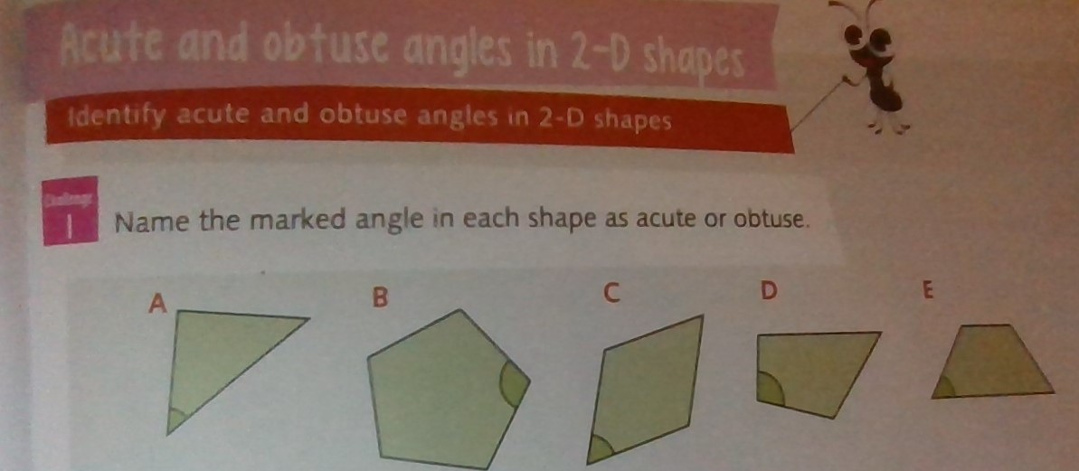

Challenge 2
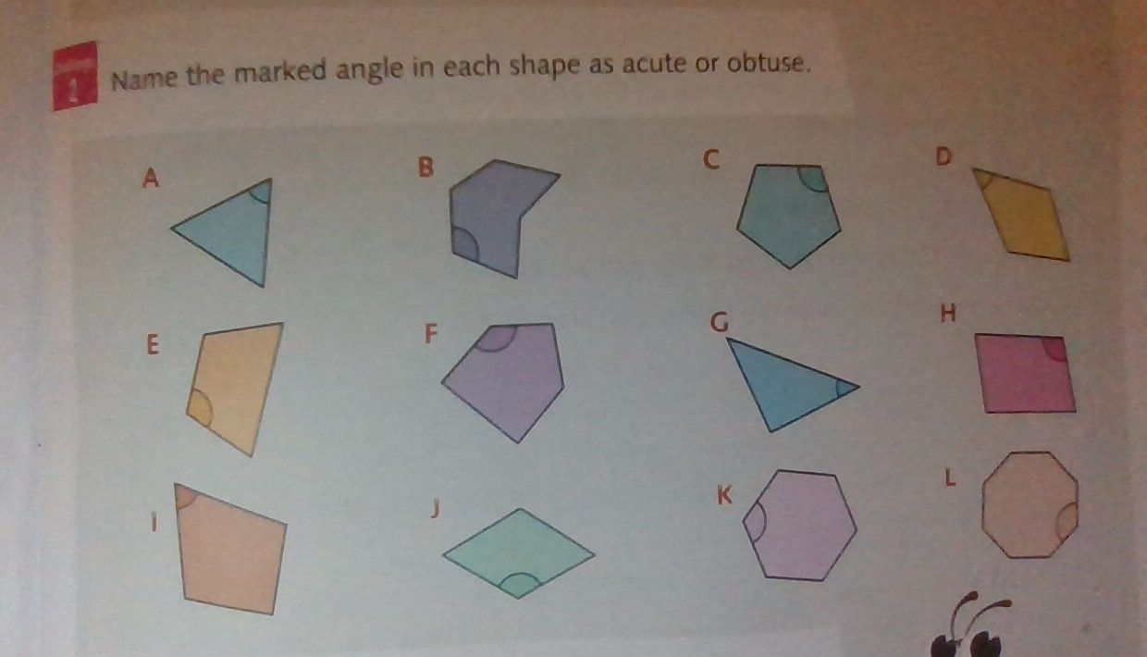

Challenge 3 ( see shapes in challenge 2 )
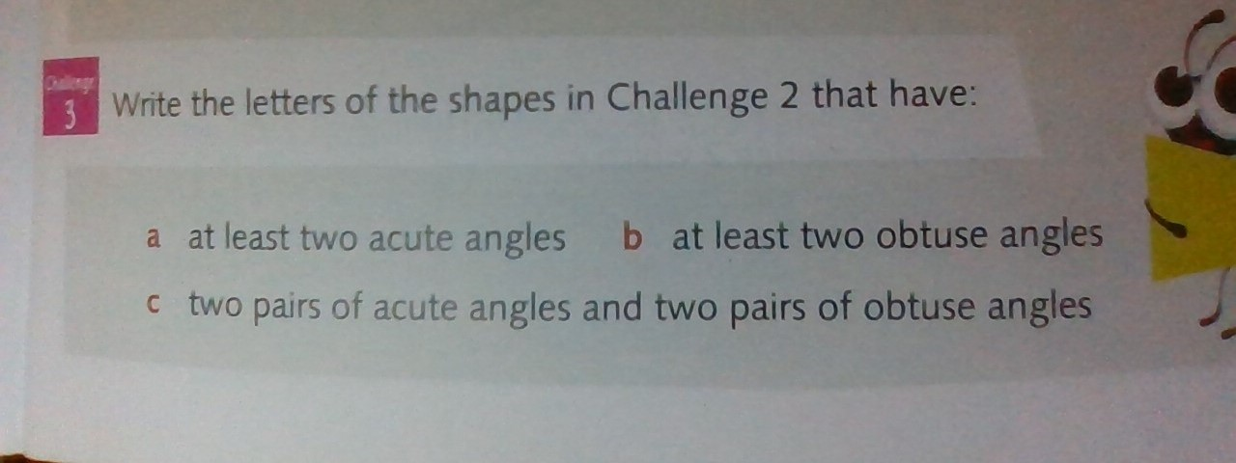

Answers for challenges 1 , 2 and 3 respectively.


