27.1.2021 maths

Challenge 1and 1ii.

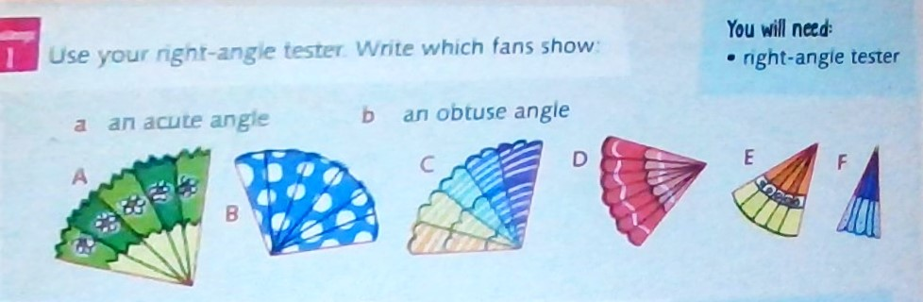
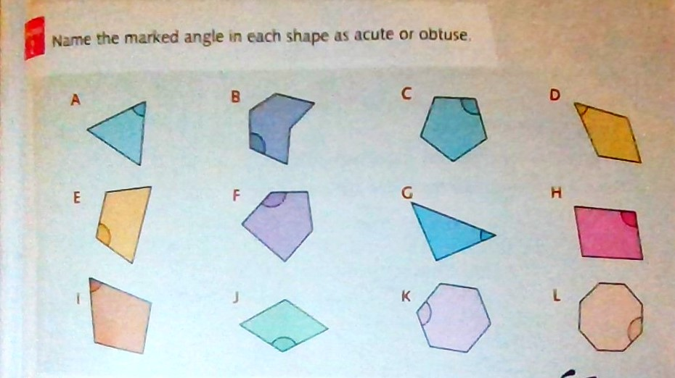
For answers to the second part of today’s Challenge 1 please see 26.1.2021
(yesterdays work ) challenge 2.

Challenge 2
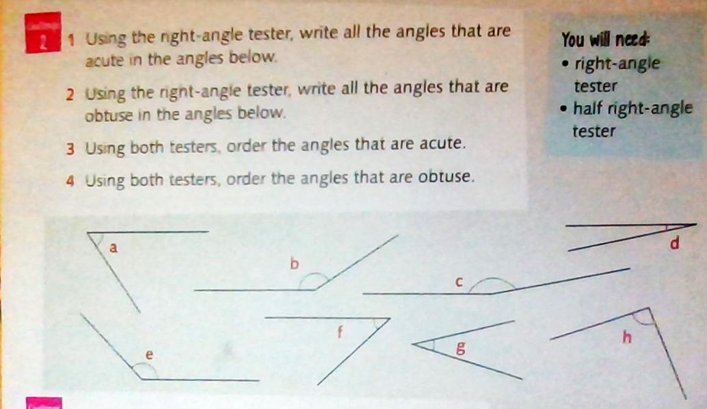

Challenge 3
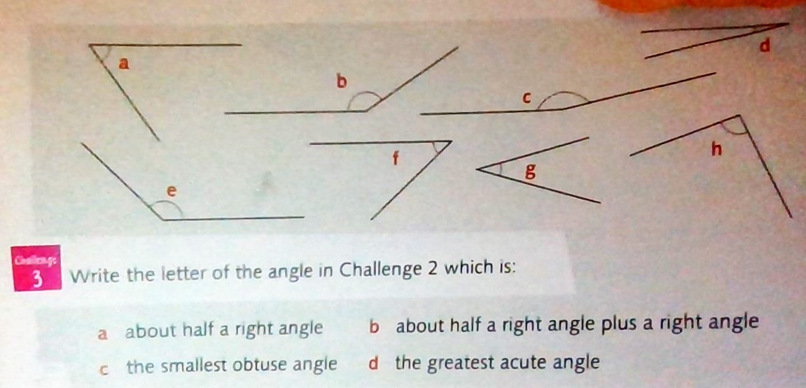

Answers

Challenge 1 please see yesterday’s answers too for part ii.



