Maths 28.1.2021 ( BA, 4B, pg 15)
All children watch BBC bitesize clip.

Challenge 1
Name these shapes ( A-I)
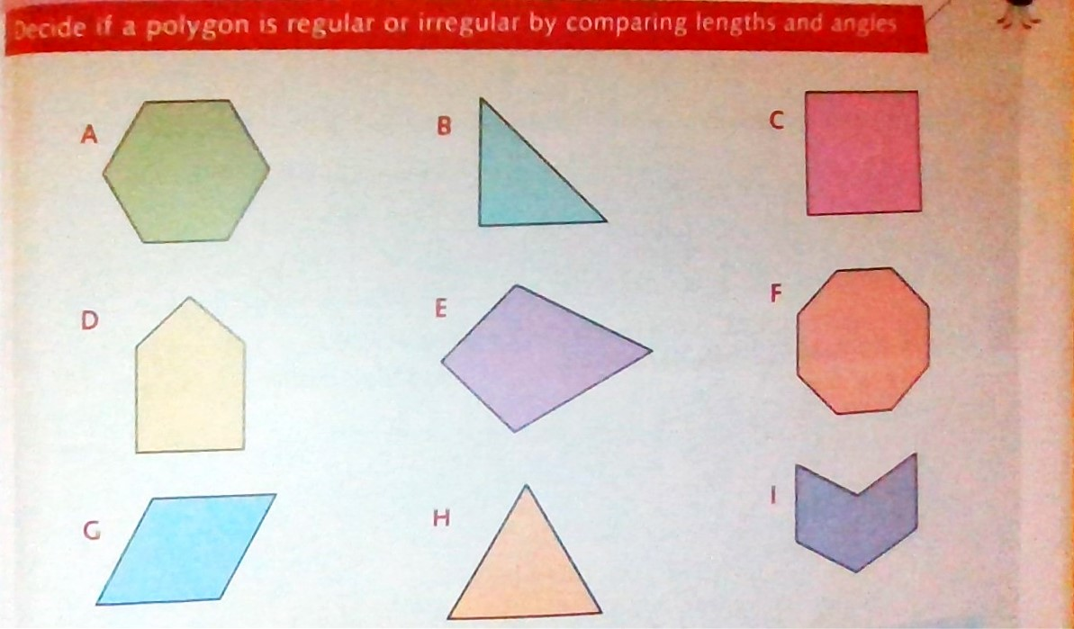

Challenge 2
Name the polygons in challenge 1 and tell me if they are regular or irregular.
Shape name | R or I?

What is a polygon?
What is a quadrilateral?
Challenge 3
Do challenge 2 first
Look for lines of symmetry in shapes A to I and complete the table .
Property | regular | irregular
One line of symmetry | A
More than one line of symmetry
ANSWERS
Challenge 1
- Hexagon
- Right angled triangle
- Square
- Irregular pentagon
- Kite
- Octagon
- Rhombus ( what is special about all sides in a rhombus? How is it different from a square? Look at the angles)
- Equilateral triangle
- Irregular hexagon

Challenge 2
Polygon- any shape enclosed with straight lines.
Quadrilateral – a 4 sided polygon ( Quad- meaning 4)

R – regular shape ( all sides are equal and all angles are equal )
I= Irregular shape (all angles are not equal and all sides are not equal)
- Hexagon | R
- Right angled triangle | I
- Square | R
- Irregular pentagon | I
- Kite | I
- Octagon | R
- Rhombus | I
- Equilateral triangle | R
- Irregular hexagon | I

Challenge 3
Property | regular | irregular
One line of symmetry |  | B D E I
More than one line of symmetry | A C F H | G

