1.2.2021 Maths LO counting in 25, 100 and 1000’s
Challenge 1 copy/ complete.
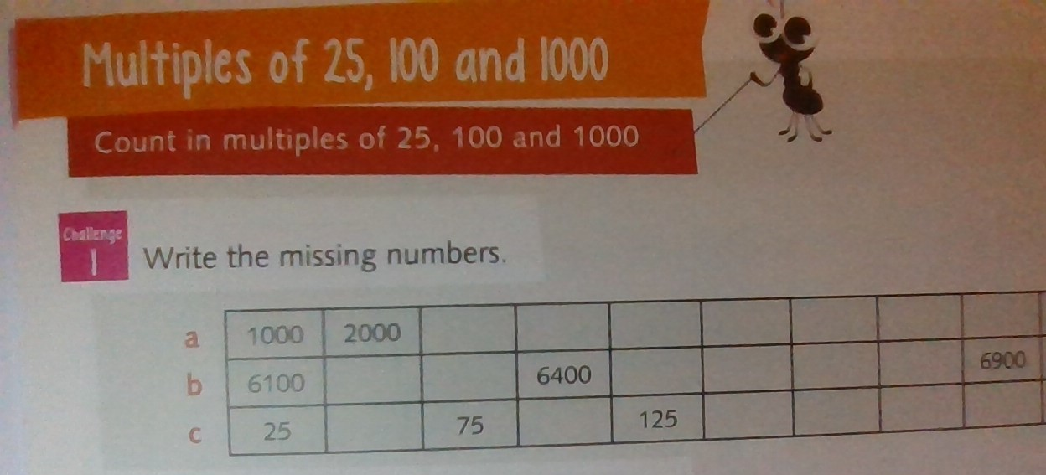
Challenge 2
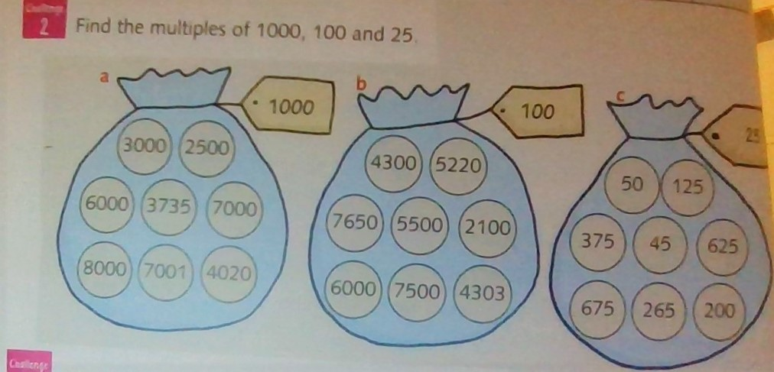

Challenge 3
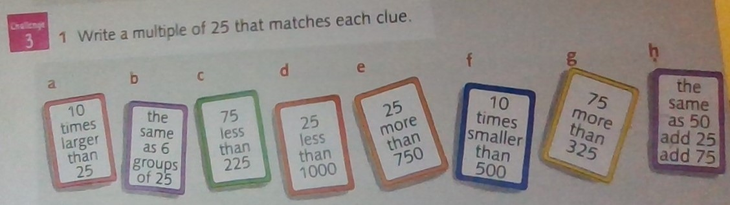

Then try 5 of these challenges. ( like we do in class)
https://nrich.maths.org/6499

Answers
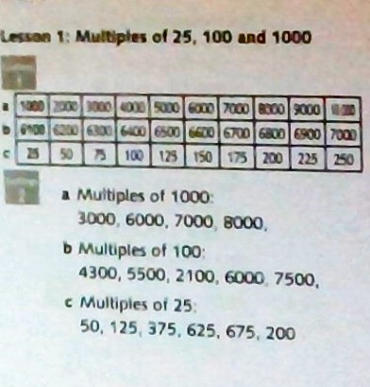

Challenge 3 answers
- 250
- 150
- 150
- 975
- 775
- 50
- 400
- 150

