3.2.2021 maths
Challenge 1 ( please write these in column form like we did yesterday)
If you end up with a 2 digit answer in the tens column and there are no other digits to multiply with then write the whole answer in the answer box. Try the sums below.
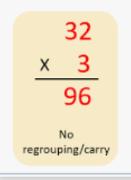
- 31x2= ( no re-grouping )
- 24x2=
- 123 x 2
- 231 x 3

- 51x3= ( last answer has 2 digits- no regrouping )
- 32x4=
- 72 x3=
- 83x3=
- 94x2=

Challenge 2
4 steps to success as below.

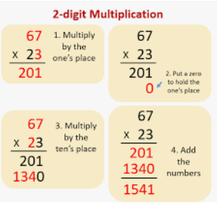
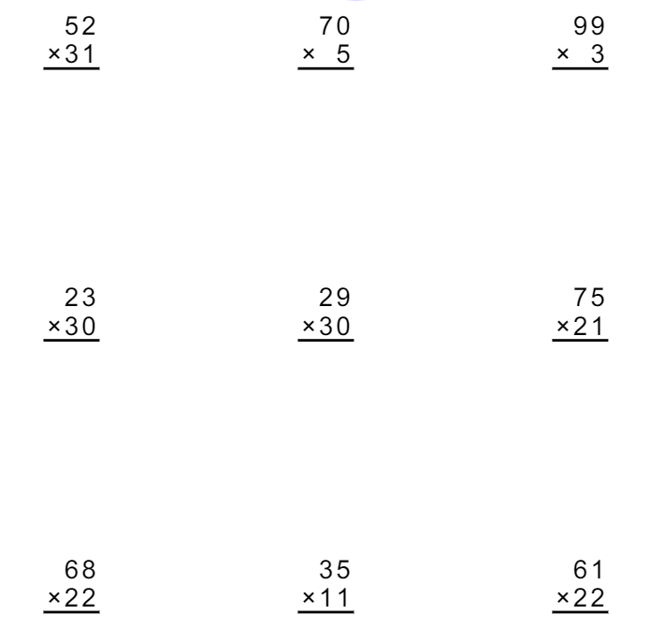

Challenge 3
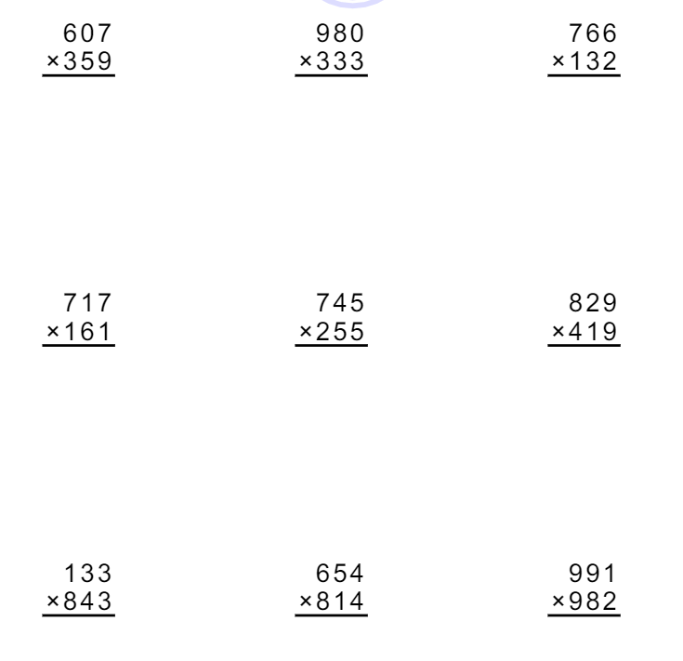

Answers

Challenge 1
- 1= 62
- 2= 48
- 3= 246
- 4= 693
- 5= 153
- 6= 128
- 7= 216
- 8= 249
- 9= 188
Challenge 2
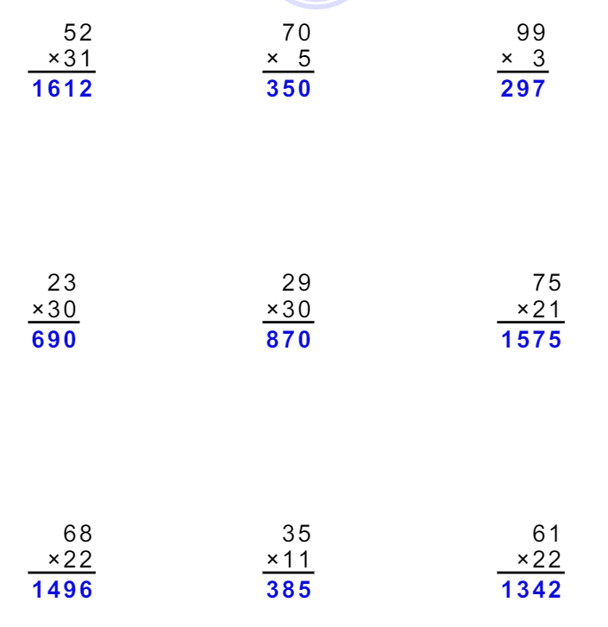

Challenge 3


