Datchet St. Mary’s
Year 4
Daily learning Sheet. Week 6.
Monday 8th February 2021.
 | Learning objective | Teaching points . | Task to complete
English | LO to revise ‘ation words . | Suffix ‘ation’ work .  You may need a dictionary or find words online.  Look up as many words ending in ‘ation ‘ | Work your way through the PP.  Slide 2 – see how many of these ‘ation’ words you can find.  Use words found on slide 2 to complete slide 3.  Mark your work on slide 4.
Maths | LO to convert between M and KM | Length. Converting between km and m  Revision of x 10, 100 and 1000 ( in particular for length)  Please Watch https://www.bbc.co.uk/bitesize/articles/z7r492  Watch the video and do the quiz- we did this back in September at the start of the year. Parents please do teach your children any tricks that may help them remember x and dividing by 10, 100 and 1000.  Reminder of conversion.  1000m = 1 km  To change m to Km multiply the number by 1000  250 m =0.250km  Do the opposite to change KM to m  2.5 km = 2500m | Ten minutes of doodle times tables please.  .  Challenge 1 + Challenge2  – see sheet challenge 1 and 2 maths 8.2.2021 + answers  Challenge3 what is a cartographer?  Can you help the cartographers convert between km and m? answers provided.  Please mark and do any corrections. Thank you .
Topic | LO- learn what it was like in Ancient Roman times. | - play the games to uncover more gruesome facts ( remember to read the Rat facts each time a game changes!)  https://www.bbc.co.uk/cbbc/games/horrible-histories-romans-vs-celts  - quiz time!  https://www.bbc.co.uk/cbbc/quizzes/horrible-histories-rotten-romans-cut-throat-celts-quiz  - mini games  https://www.bbc.co.uk/cbbc/games/horrible-histories-romans-vs-celts  funny statue heads  https://statues.vanderkrogt.net/object.php?webpage=ST&record=gbse135  heads of Emperors  https://www.ancient.eu/article/677/visual-chronology-of-roman-emperors-augustus-to-co/  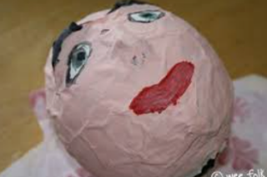 you decide your design.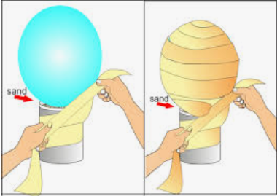  Draw if you don’t have the resources or make it out of dough and paint it when it’s dry.  Be creative ! | - Play the games. Links on the left.  - The Roman’s loved sculptures.  Can you make a sculpted head out of paper and a balloon/ plastic bowl. Cut up pieces of newspaper/paper, use mixture of flour and water as paste. You could model your own head . See this link – these made me smile.  Let your sculpted head dry out and paint it tomorrow.

