Maths 8.2.2021
Challenge 1
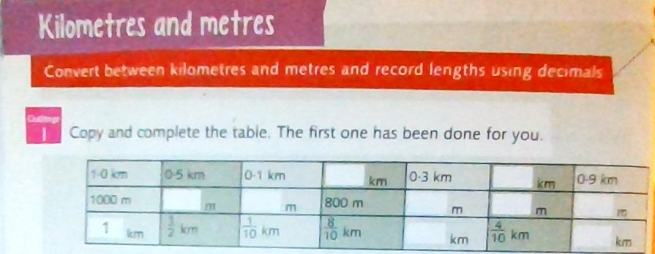

Challenge 2
Please do parts 1, 2 and 3 of challenge 2,
Part 4 is optional if you are feeling very confident.
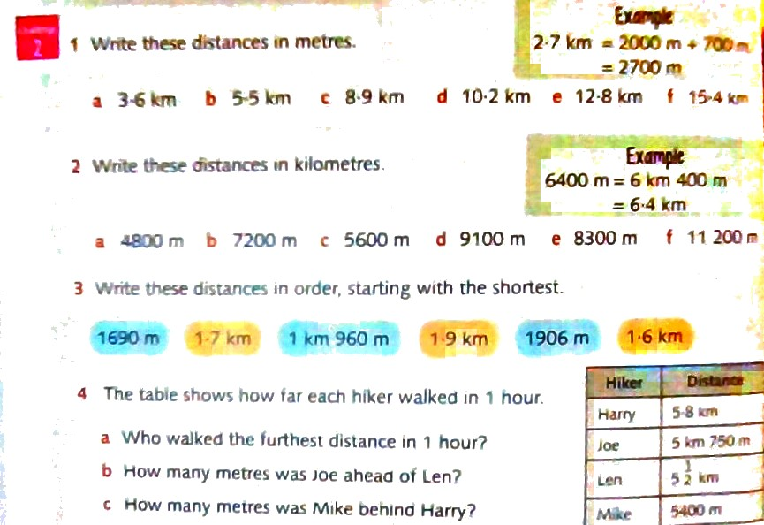
Answers


