9.2.2021 Maths

Challenge 1 please do qns 1 and 2 building on yesterdays work
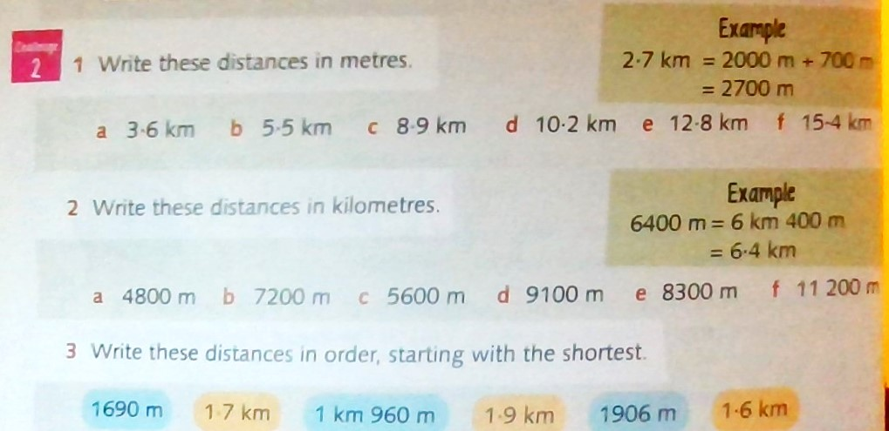
Challenge 2

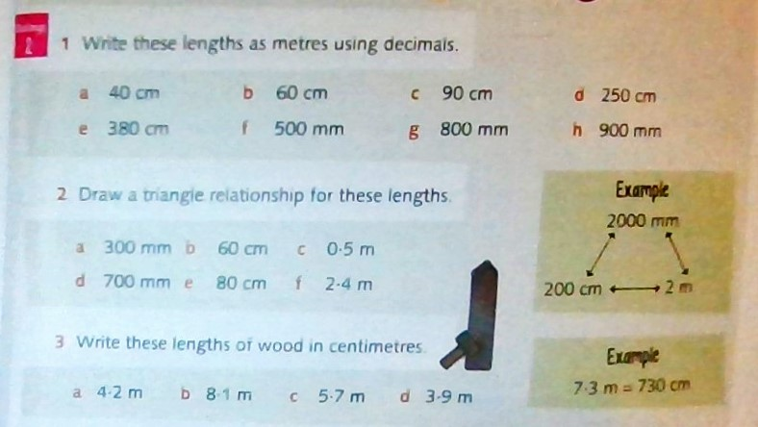

Challenge 3 PART 1
please do qn 3, qn 4 and challenge 3.
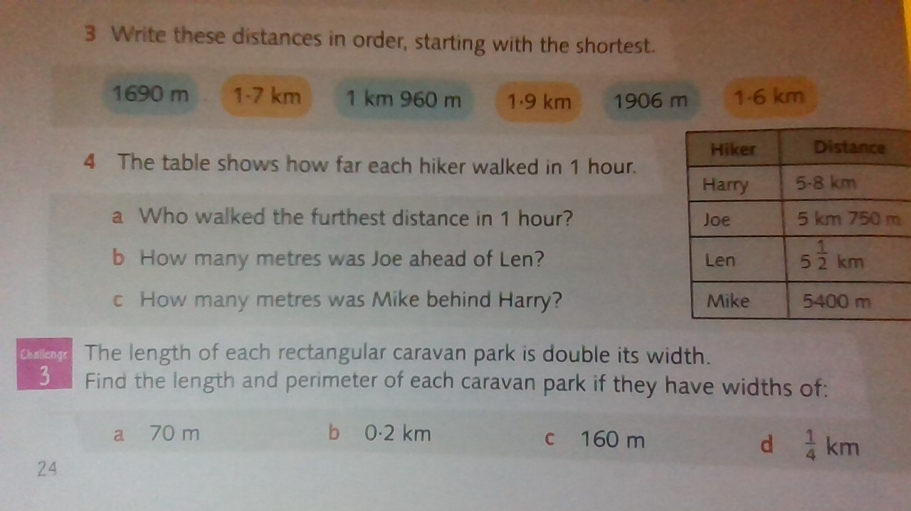
Challenge 3 part 2
Start from qn 3 part a, do qn 4 and then challenge 3.
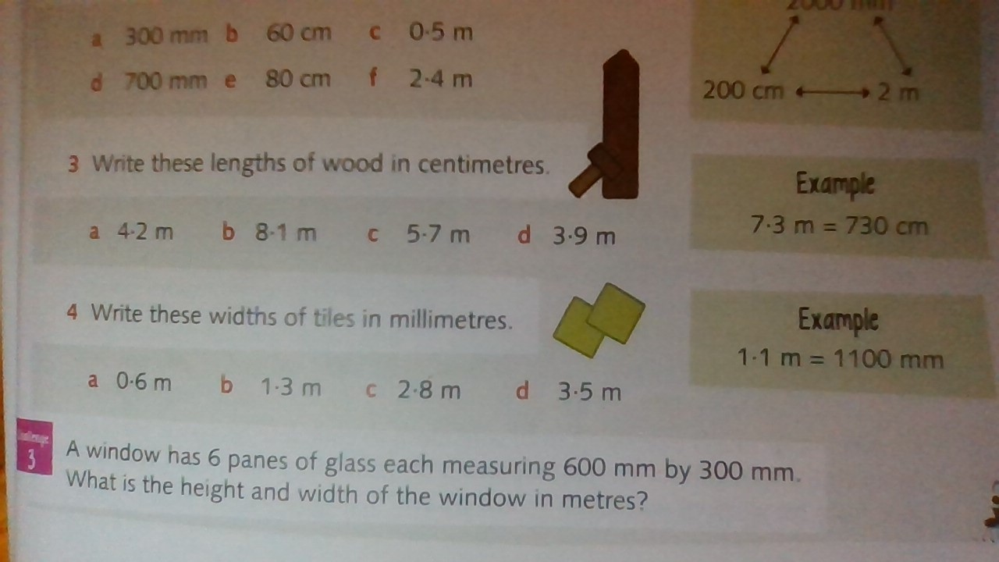

Answers
Challenge 1
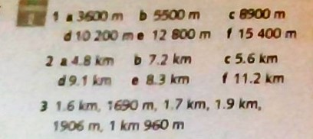

Challenge 2
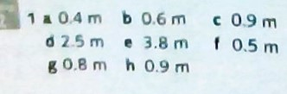

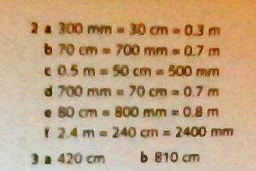
C 570 cm d 390 cm

Challenge 3 part 1
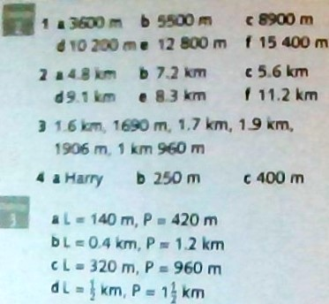
Challenge 3 Part 2


