Grammaticus application for the Augustulus household.
URGENTLY REQUIRED :
GRAMMATICUS to a set of twins aged 9 ( 2 boys) Essential knowledge of reading and writing Latin using a stylus and a wax tablet, maths using an abacus and good behaviour management ( use of canes and whips permitted ) Teaching skills in oration and public speaking is vital . As a tutor you will undertake a test before the job begins.
Although not common , we would prefer to employ someone who could also educate our 12 year old girl. Basic reading and writing preferred before marriage.
Basic pay per month......... 200 denarius upto 250 for a teacher of rhetoric (public speaking) specialism.
To apply for this job you must include a letter of application . This should include the following sub-headings.

Remember – best writing and editing required before submitting this application.

Your (Roman) name at the top and the Job you are applying for.
paragraph 1 us about the skills and experience you have that are perfect for this job. You can interview your Class/ Home school teacher for ideas !
Paragraph 2 - Why do you want to apply for this job .

Paragraph 3 Why we should pick you above anybody else?

Paragraph 4 Anything extra you could bring to this role.

Signature and date.

Use the editing checklist below to check and improve your work. I always find reading my work aloud to someone really helps me check that it makes sense.

Editing checklist.

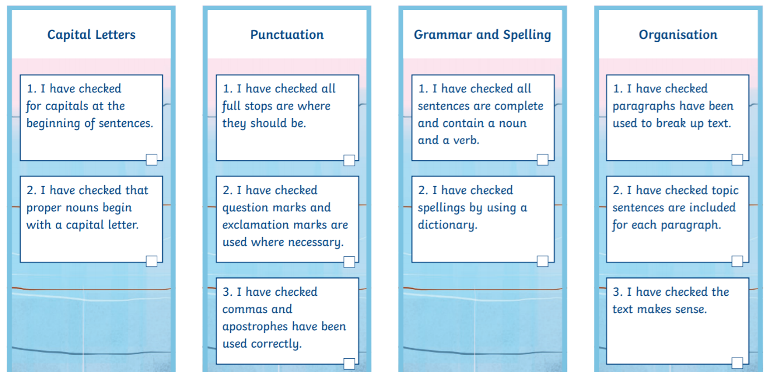

I have not included inverted commas in my punctuation list for this work. Remember you will not find everything in one piece of writing.

