10.2.2021 Maths

Challenge 1 please do challenge 1 and try challenge 2
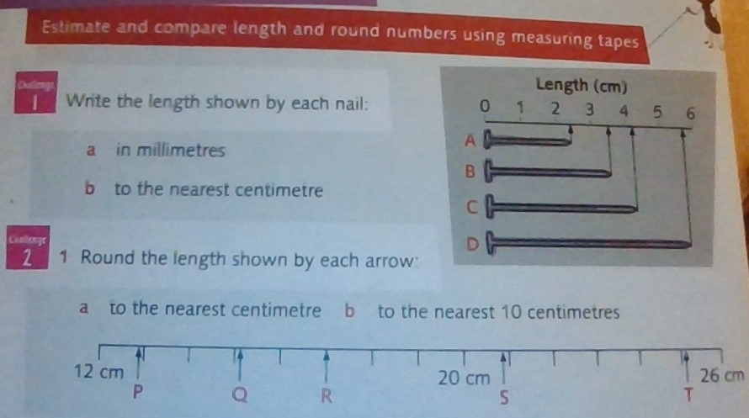
Challenge 2
Please do challenge 2 a, 3 a and b . Try challenge 3 at the bottom if you are feeling confident. 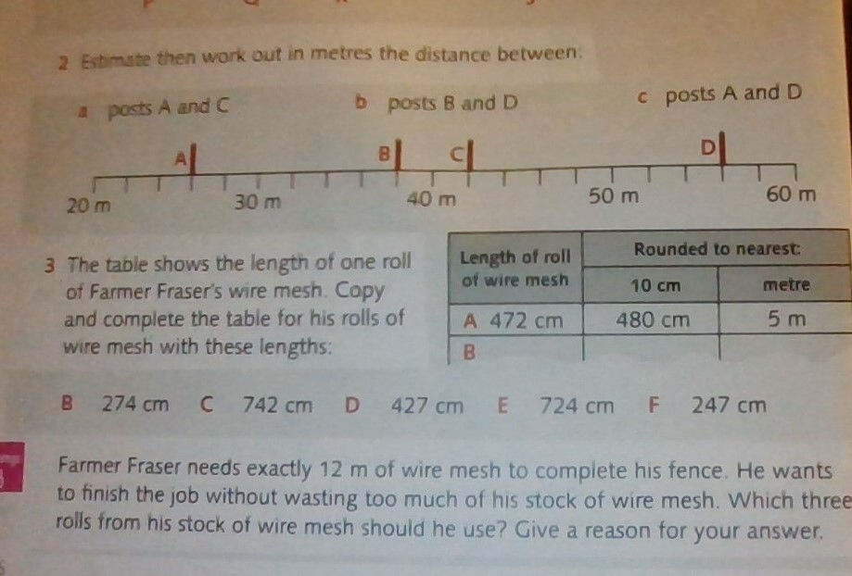

Answers
Challenge 1 Challenge 2



