Maths 11.2.2021
Challenge 1

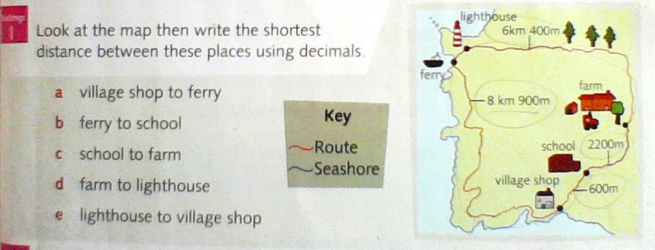

Challenges 2 and 3
The lighthouse is 60.9metres tall. The height of the school building is 20 m and 30 cm
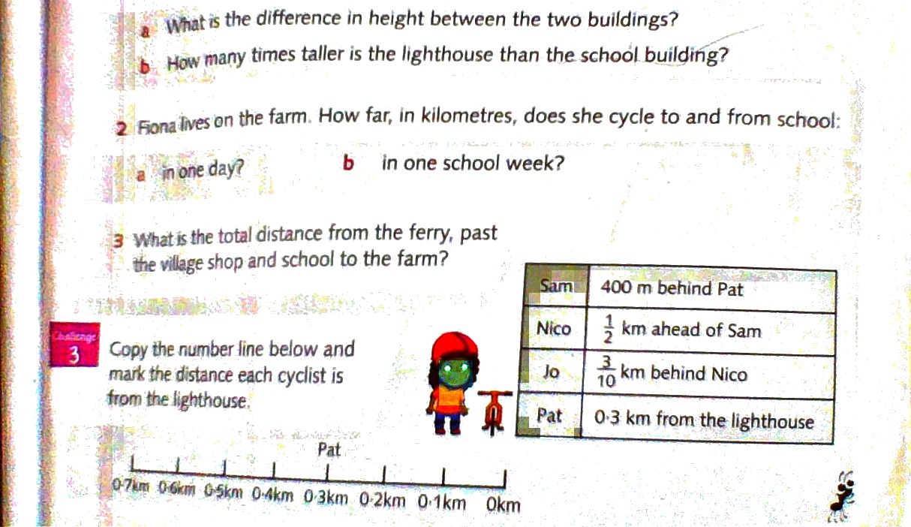

ANSWERS



