22.2.21 Mind Mapping Lockdown life
Decide who you will write your letter to – friends, family, front- line workers , your teachers , somebody living in a care home?
Challenge 1
You’d write Lockdown life/ Coronavirus in the middle bubble then perhaps around the edge you could brainstorm different parts of your life that have changed because of it for example-
Family friends school Home how it makes me feel.
Add a few notes /words around each bubble which will help you to remember what you want to write tomorrow,

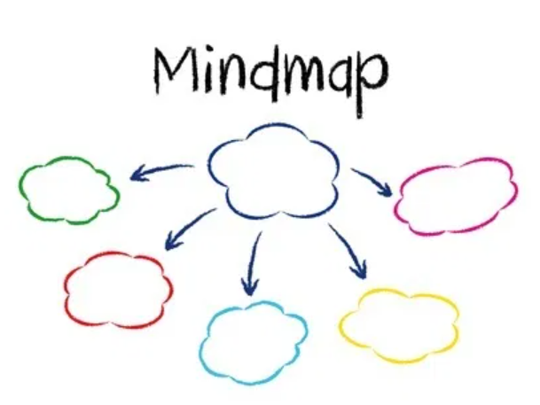
Challenge 2. You may like something like this ….
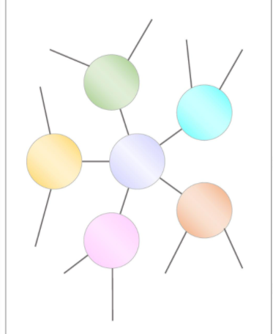

Challenge 3

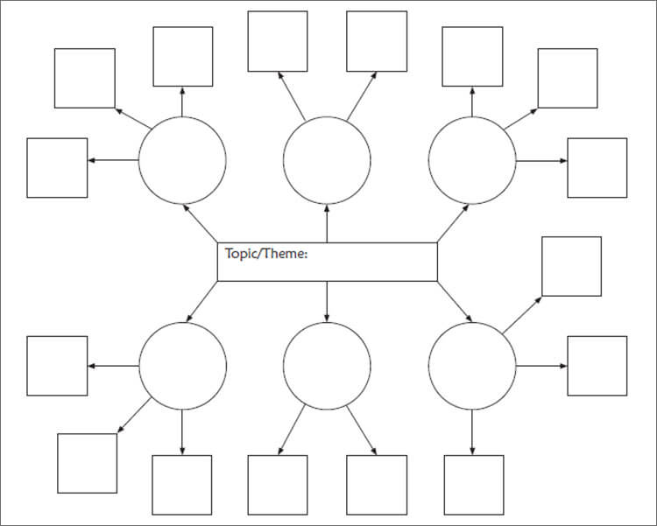

In your visual planning template you are basically going to gather your ideas today about lockdown. You choose your challenge .
What areas of your life has Lockdown changed? How have you made the best of your situation? How have you remained positive ?
You will need to have thought this through for tomorrow’s lesson.

