25.2.21
Finding area ( by counting squares or using multiplication )
Challenge 1 ( do challenges 1 and 2)
Challenge 2 ( do challenges 2 and 3)
Challenge 3 see page 3 below.
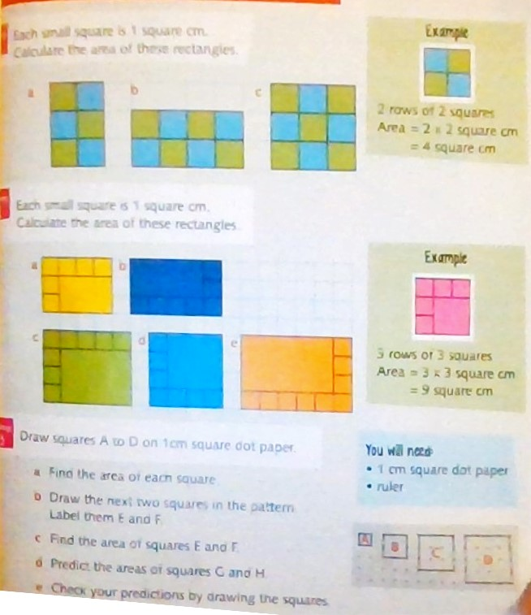

Challenge 3 is on page 3 of this document.

answers Challenge 1
A= 6 cm²
B= 8 cm²
C= 12 cm²

Challenge 2
- 12 cm²
- 15 cm²
- 20 cm²
- 16 cm²
- 24 cm²

Challenge 3
A= 1 cm²
B=4 cm²
C= 9 cm²
D=16 cm²
E= 25 cm²
F=36 cm²
G=49 cm²
H=64 cm²

Challenge 3
Please watch lesson 8
https://classroom.thenational.academy/units/area-and-perimeter-ea69
and answer the questions, take the quiz
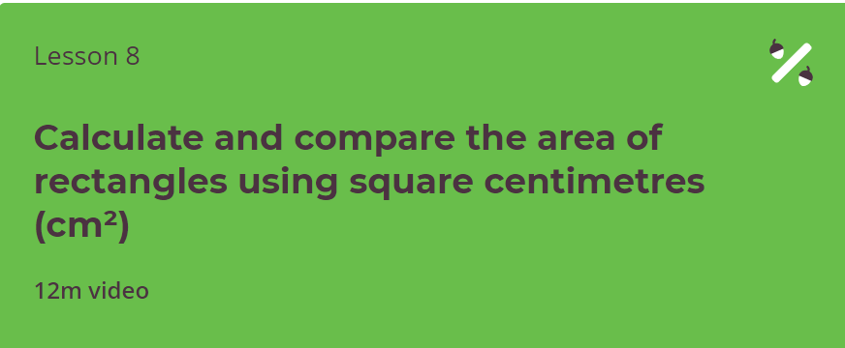
And same with lesson 9 please.

