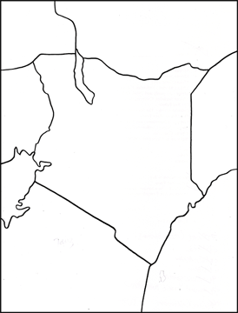
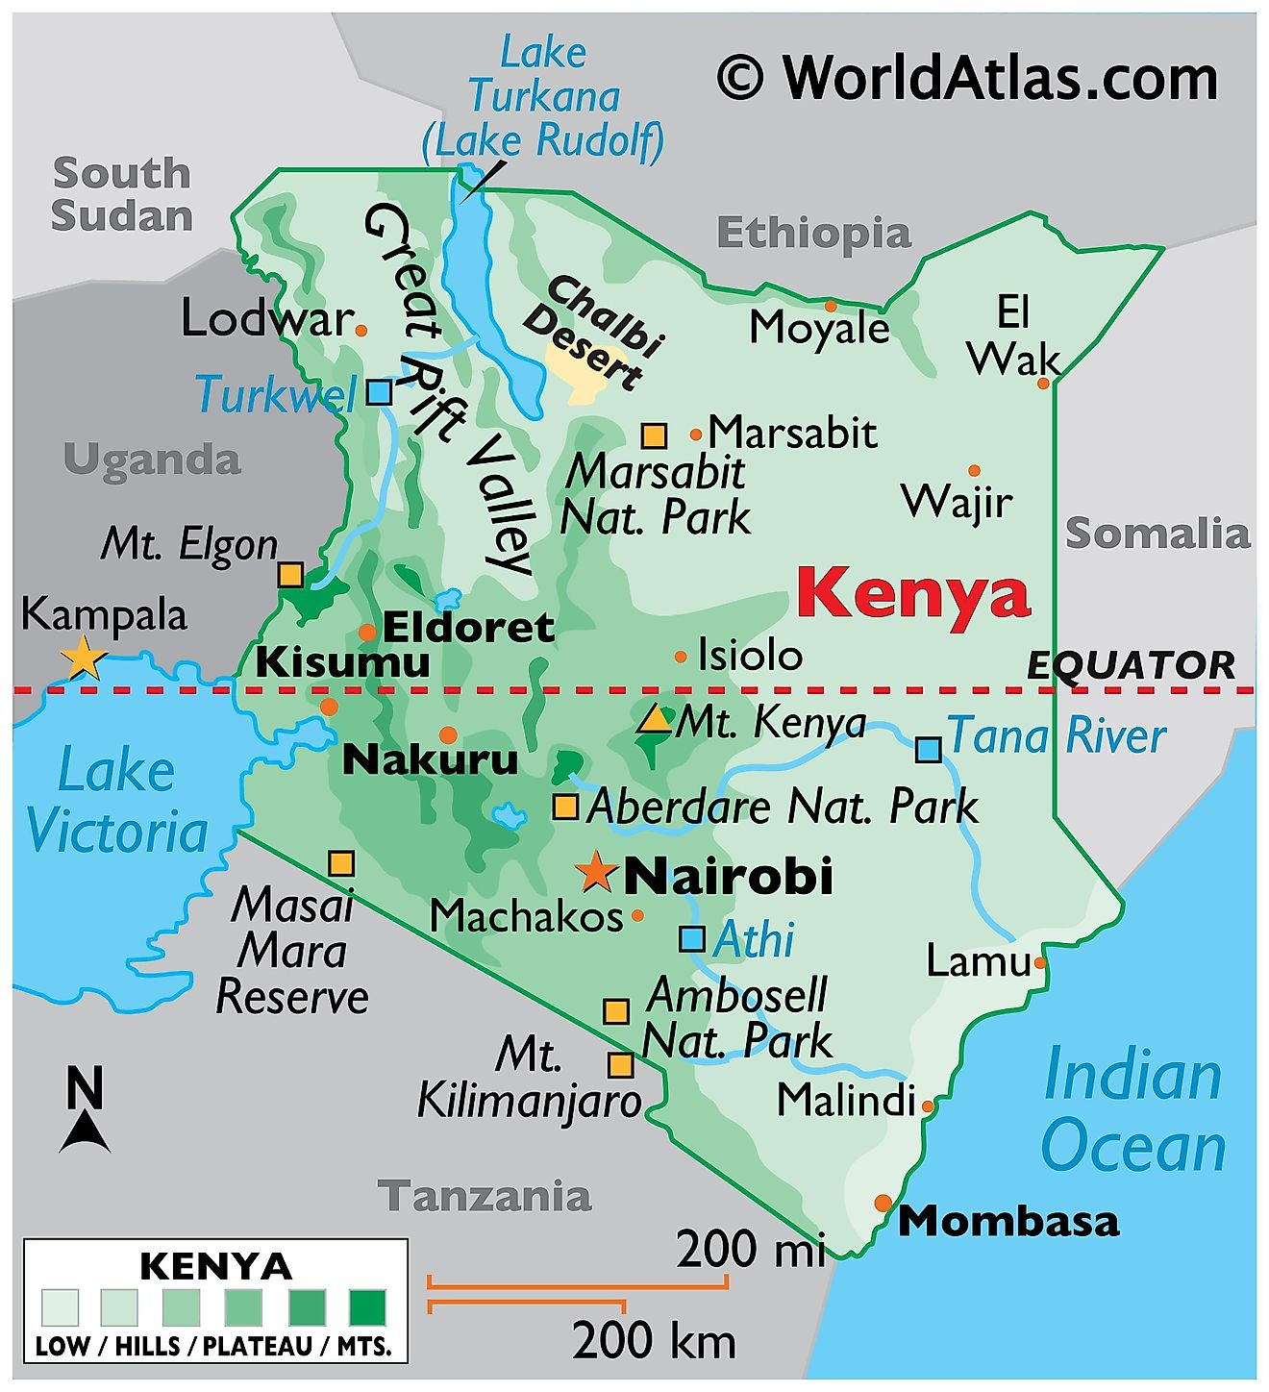
Locate and label the following on your map:
- Nairobi
- Mombasa
- Mt Kenya
- The 5 neighbouring countries
- The 2 large lakes
- The Indian Ocean
- The Tana River


