Make your chatter mouths.
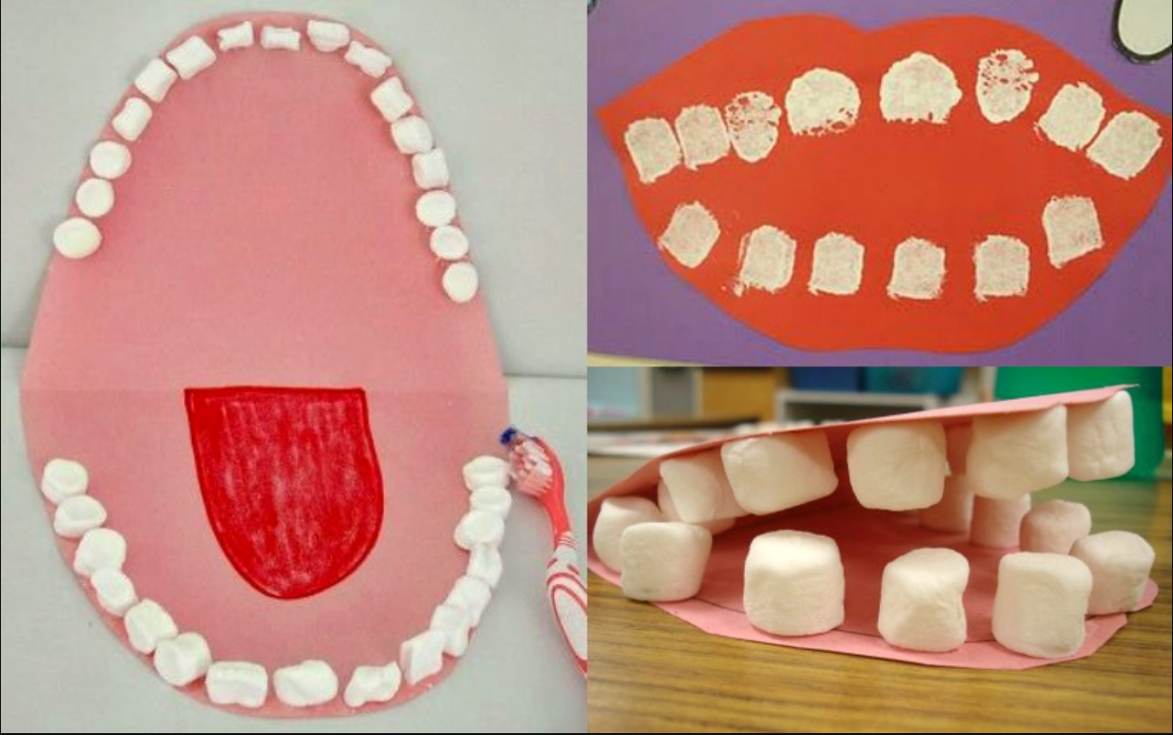

Cut out the oval ,
Fold along the 2 At the end stick a strip of paper on the top
Lines in the middle jaw and one on the bottom so you can
To create a top jaw put your fingers through and move your
and lower jaw. Chatter mouths open and shut!
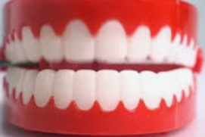
Use mini Use whatever colours you have available.
marshmallows or
cut out the different
teeth and stick them on
the insides of the jaws.

