Monday 1st March 2021
Challenge 1
LO to write 2 related division facts for x table sums.
 | X table sum | Write 2 related division facts.
eg | 7 x 3 = 21 | 21 7 = 3 and 21 3 =7
 | 5 x 11=
 | 10 x 5=
 | 2 x 7=
 | 11 x 7=
 | 5 x 9=
 | 10 x 3=
 | 2 x 9=
 | 11 x 6=
 | 5 x 7=
 | 2 x 8=
 | 3 x 8=
 | 10 x 9=

Challenge 2
Dividing by multiples of 10.
You may want to revise x and dividing by 10 and 100s
https://www.bbc.co.uk/bitesize/topics/z36tyrd/articles/z2fkwxs

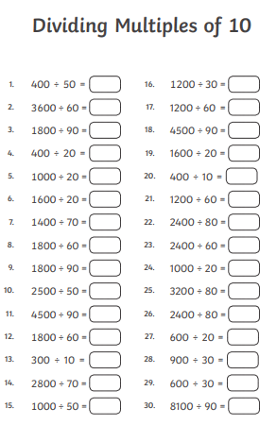

Challenge 3
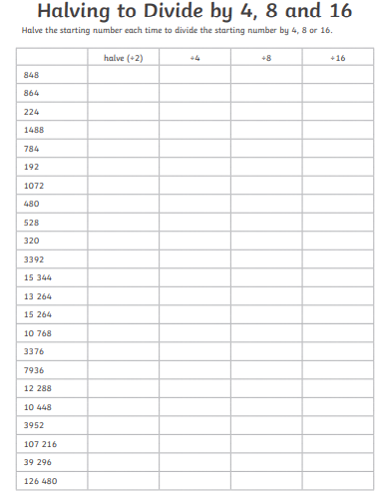

ANSWERS
Challenge 1 answers
 | X table sum | Write 2 related division facts.
eg | 7 x 3 = 21 | 21 7 = 3 and 21 3 =7
 | 5 x 11=55 | 5511= 5 and 55 5= 11
 | 10 x 5=50 | 50 5= 10 and 50 10 = 5
 | 2 x 7=14 | 14 2 = 7 and 14 7 = 2
 | 11 x 7=77 | 77 11= 7 and 77 7 = 11
 | 5 x 9=45 | 45 9=5 and 45 5=9
 | 10 x 3=30 | 30 3=10 and 30 10= 3
 | 2 x 9=18 | 18 9 = 2 and 18 2 = 9
 | 11 x 6=66 | 66 6 = 11 and 66 11= 6
 | 5 x 7=35 | 35 5= 7 and 35 7 = 5
 | 2 x 8=16 | 16 2= 8 and 16 8= 2
 | 3 x 8=24 | 24 8 = 3 and 24 3 = 8
 | 10 x 9=90 | 90 9 = 10 and 90 10 = 9

Challenge 2 answers
Dividing by multiples of 10
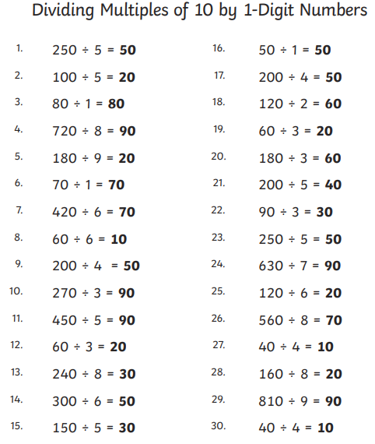

Challenge 3 answers



