What animal do these teeth belong to ? How did you work out your answer ?
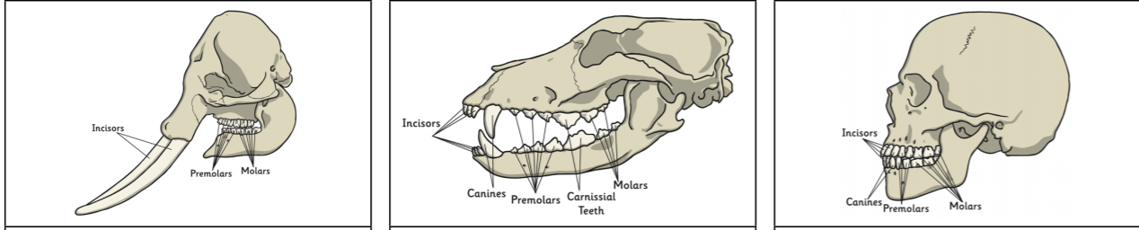
A B C

What is the same and what is different about the teeth in A, B or C?
What do you think the diet of these animals is like?
Does that explain what type of teeth they have ?


