Complete the calculations below.

1. |  | 7 | 7 | 7 |  |  |  | 2. |  | 7 | 9 | 8 |  |  |  | 3. |  | 4 | 6 | 4
4. |  | 7 | 9 | 1 |  |  |  | 5. |  | 7 | 1 | 5 | 4 |  |  | 6. |  | 3 | 2 | 0 | 4

7. 138 ÷ 6 = 8. 217 ÷ 7 =

- Connor had 91 marbles. He shared them out equally between 7 bags. How many marbles were in each bag?


- A baker bakes 132 cupcakes. She sends them to 6 different supermarkets. How many cupcakes does each supermarket receive?


Short Division Without Remainders - Answers

1. 11
2. 14
3. 16
4. 13
5. 22
6. 68
7. 23
8. 31
9. 13
10. 22

Complete the calculations below.

1. |  | 3 | 8 | 1 |  |  |  | 2. |  | 4 | 7 | 2 |  |  |  | 3. |  | 6 | 1 | 7 | 4
4. |  | 4 | 2 | 7 | 2 |  |  | 5. |  | 8 | 3 | 4 | 4 |  |  | 6. |  | 7 | 4 | 3 | 4

7. 294 ÷ 6 = 8. 744 ÷ 3 =

9. 1256 ÷ 8 = 10. 1076 ÷ 4 =

- Grandma Jones had £378 which she shared equally between her 7 grandchildren. How much money did each grandchild receive?
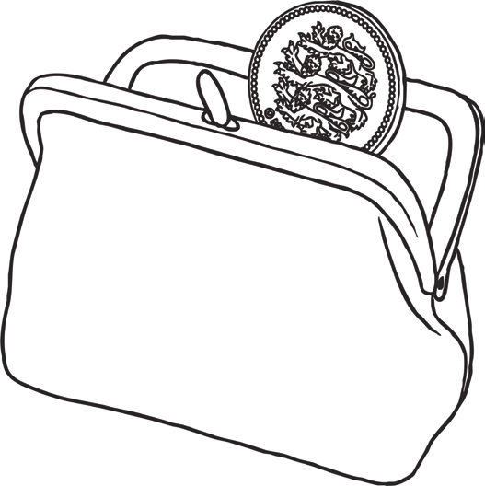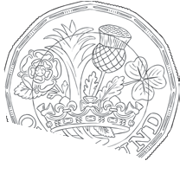

- 1134 train passengers are given tickets to sit in 9 different carriages. How many passengers are in each carriage?
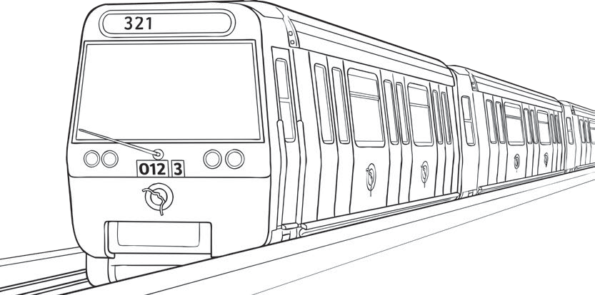

Short Division Without Remainders - Answers

1. 27
2. 18
3. 29
4. 68
5. 43
6. 62
7. 49
8. 248
9. 157
10. 269
11. £54
12. 126

Complete the calculations below.

1. |  | 3 | 2 | 6 | 1 |  |  | 2. |  | 4 | 2 | 1 | 0 | 4 |  | 3. |  | 6 | 1 | 3 | 8 | 6
4. |  | 4 | 1 | 4 | 7 | 2 |  | 5. |  | 8 | 5 | 2 | 3 | 2 |  | 6. |  | 7 | 5 | 7 | 6 | 8

7. 5094 ÷ 6 = 8. 2253 ÷ 3 =

9. 6072 ÷ 8 = 10. 3996 ÷ 4 =

- A factory packs 5232 cans of beans into 8 crates. How many cans will be in each crate?


- Giles plans to cycle a distance of 1098 miles for charity. He decides to split the journey equally over 9 days. How many miles will he need to travel each day to reach his target?
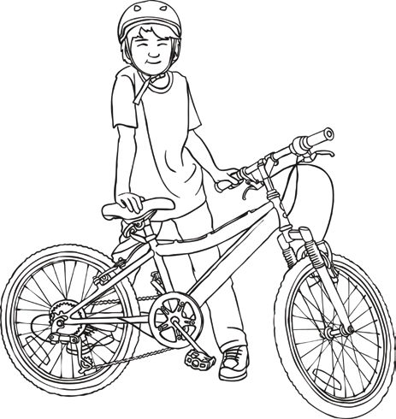

- 6713 seven-year-old children in a town near Liverpool are allocated one of 7 schools. If the children are split amongst the schools equally, how many children will go to each school?
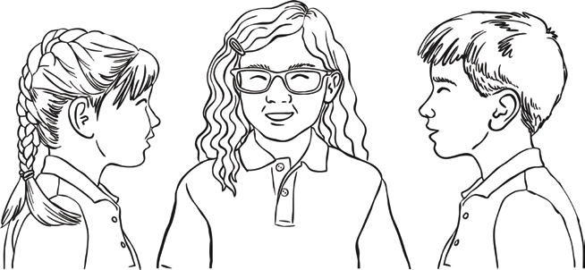

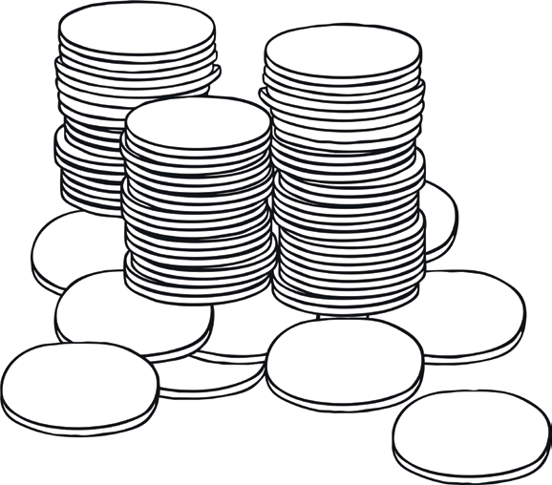
- Charlie has £8652 in savings. He decides to put the money in 4 different savings accounts. How much money will he put in each account?

Short Division Without Remainders - Answers

1. 87
2. 526
3. 231
4. 368
5. 654
6. 824
7. 849
8. 751
9. 759
10. 999
11. 654
12. 122 miles
13. 959
14. £2163

