3.3.2021 English character profile for __________________________________________

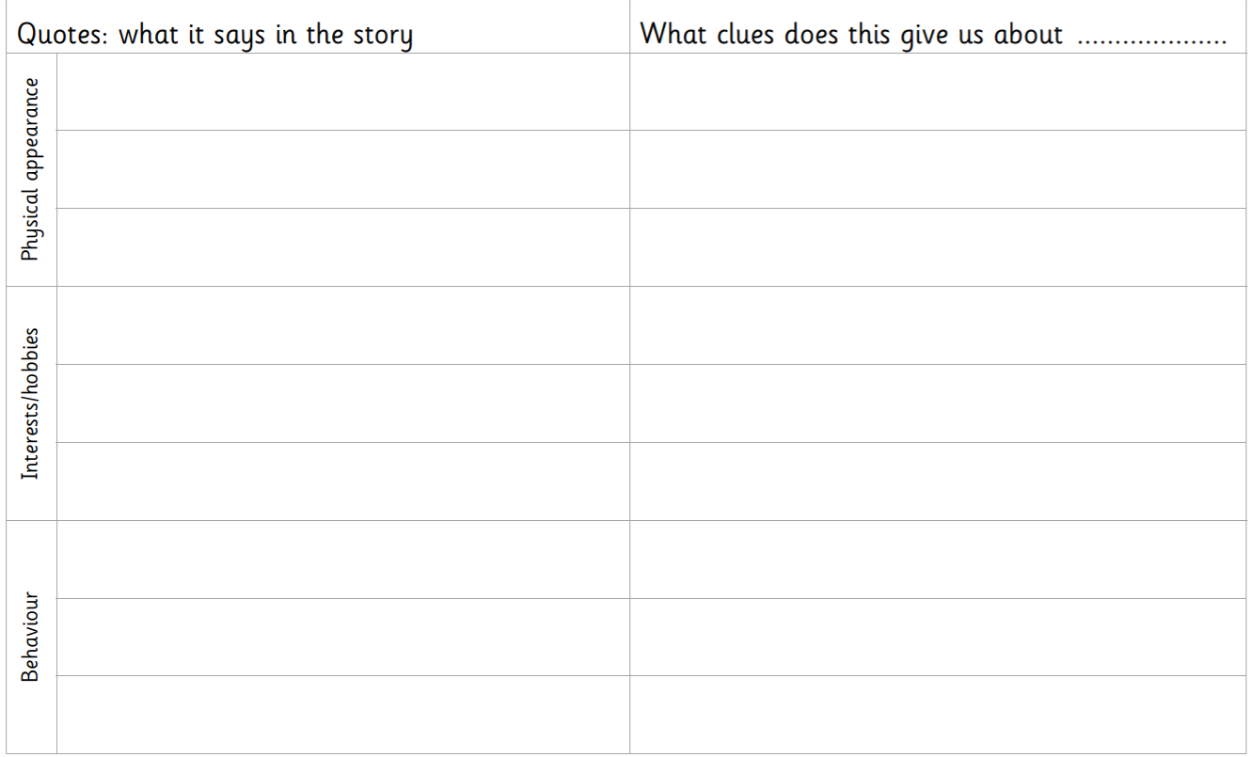

_{Support for the adults} ( incase the children struggle)



