Diary entry of a Meal’s journey.

Success criteria
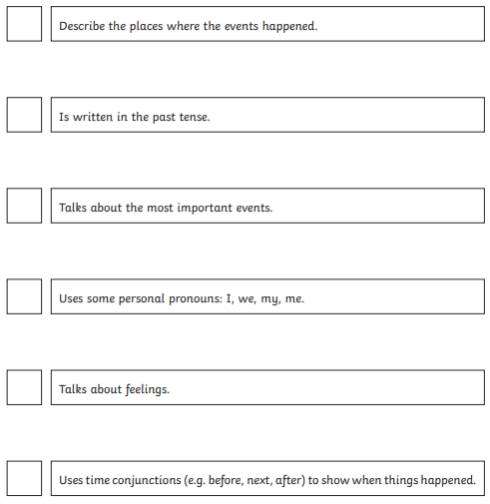
In the mouth- teeth attack! | Well you’ll never guess what happened today ! I was hanging out with pepper and mushroom on a slice of pizza when all of a suddenly….. | 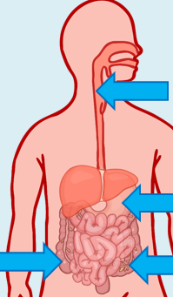  If you need to, watch the BBC videos to inspire you to write some sentences in each box.  You must use these words in your diary entry .
Travelling down the ‘long tube’ | Before I could say vegetables, I found myself being drawn towards a black hole, I couldn’t see anything beyond….
In the stomach
In the small intestine
In the large intestine


