Datchet St. Mary’s
Year 4
Daily learning Sheet. Week 8.
Friday 5th March 2021. Art Day
11.30- catch up – remember to dress up if you can! There will be a book related scavenger hunt today
 | Learning objective | Teaching points . | Task to complete
English | LO I can plan and create a piece of art reflecting my emotions and experiences of these unusual times | Paint a memory  Home school Learning Art You will need to print off the Art template sheet (2 copies if you are at home) or draw the template on a plain piece of paper | Look at the PP for inspiration- do not simply copy a design, create your own.  Task 1: Plan your piece of art using the template  Task 2: Create your piece of art using a second copy of the template (or a 15cmx 15cm square on plain paper) You can chose whether to use paint, pens, pencils or collage. (In school you will be given your resources to do Task 2)  You need to bring your painting/masterpiece to school on Monday 8th March where we will share the ideas behind your art work.
Topic | LO- cook a simple Italian dish – optional to celebrate the last day of Lock down. | 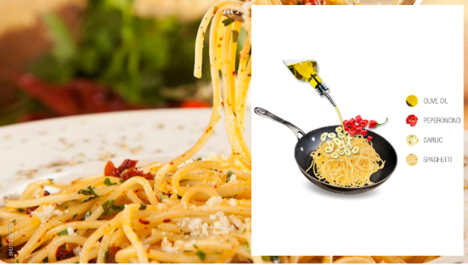  Spaghetti aglio e olio | 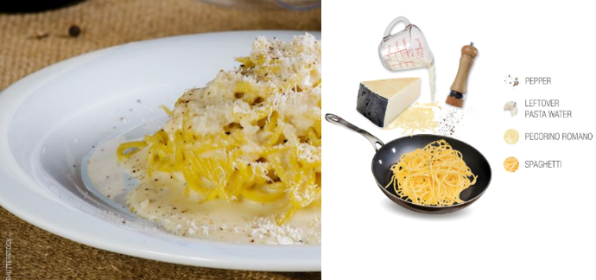  Cacio e pepe- a favourite Roman dish as the ingredients were simple and long lasting
I will see you soon. Go to sleep earlier on Sunday so that you are fresh and ready for school again


